

RESEARCH REPORT

Project name

28 February, 2022

Report title can be several lines long report title can be several lines long report title can be several lines long

Sub-heading here if needed

Author 1, Author 2

Author 3, Author 4 etc



Please add two project images: one here and one to the right, and project collaborator logos below

Delete this text:

Questions or help with this template:   
Sarah.Gracie@utas.edu.au

This template is available on the NESP Marine Biodiversity Hub website in the Secure Documents

Milestone number: insert

Research Plan number: insert

Please address inquiries to: insert contact name and details

Preferred citation

Author/editors (year) First Level Report Heading: Second Level Report Heading. Report to the National Environmental Science Program. Lead organisation.

Copyright

© List home organisation of all authors (Year)

This report is reproduced and made available under the following licence from the copyright owners:

Creative Commons Attribution 4.0 Australia Licence.

For licence conditions, see <https://creativecommons.org/licenses/by/4.0/>

Acknowledgement

This work was undertaken for the Marine and Coastal Hub, a collaborative partnership supported through funding from the Australian Government’s National Environmental Science Program (NESP).

NESP Marine and Coastal Hub partners

The Australian Institute of Marine Science, Bioplatforms Australia, Bureau of Meteorology, Charles Darwin University, Central Queensland University, CSIRO, Deakin University, Edith Cowan University, Flinders University, Geoscience Australia, Griffith University, Integrated Marine Observing System, James Cook University, Macquarie University, Murdoch University, Museums Victoria, NSW Department of Planning and Environment (Environment, Energy and Science Group), NSW Department of Primary Industries, South Australian Research and Development Institute, The University of Adelaide, University of Melbourne, The University of Queensland, University of New South Wales, University of Tasmania, University of Technology Sydney, The University of Sydney, University of Western Australia, The University of Wollongong

Disclaimer

The NESP Marine and Coastal Hub advises that this publication comprises general statements based on scientific research. The reader is advised and needs to be aware that such information may be incomplete or unable to be used in any specific situation. No reliance or actions must therefore be made on that information without seeking prior expert professional, scientific and technical advice. To the extent permitted by law, the NESP Marine and Coastal Hub (including its host organisations, employees, partners and consultants) excludes all liability to any person for any consequences, including but not limited to all losses, damages, costs, expenses and any other compensation, arising directly or indirectly from using this publication (in part or in whole) and any information or material contained in it.

Cover images: (credit where required)

This report is available on the NESP Marine and Coastal Hub website:

www.nespmarinecoastal.edu.au

Contents

**Automatic Generation of table of contents**

* using Heading 1, Heading 2 and Heading 3 styles throughout your report will allow your table of contents to generate automatically
* To update the Table of contents, **Right click** on table of contents and click **‘Update Field’** then select the options of “Update entire table”

Executive summary 1

1. Introduction 2

2. How to use this report template 3

3. Styles 4

3.1 Using styles 4

3.2 Page breaks, section breaks and page numbering 5

3.3 Headers and footers 5

3.4 Use the Caption feature to label figures and tables 5

3.4.1 How to label a caption 5

3.4.2 Figure and caption example 5

3.4.3 Tables using the Caption Style example 7

3.5 Equation formatting 7

4. Troubleshooting graphics and images 8

How to format the image/graphic 8

5. Style examples 9

Heading 1 9

Heading 2 9

Heading 3 9

Heading 4 9

6. Typical report sections 10

6.1.1 Executive summary 10

6.1.2 Introduction 10

6.1.3 Methods 10

6.1.4 Results 10

6.1.5 Conclusions 10

6.1.6 Recommendations 10

6.1.7 References 10

6.1.8 Appendices 10

Appendix A 11

Appendix B 12

**Table of Contents for captions, figures and tables**

Use the Caption feature to label figures, tables and other items in order to generate a table of contents for these items.

Access the Caption feature via the **References** ribbon/ **Insert Caption**. Customise the label by adding additional text relevant to your item. This feature will automatically use the Caption style for formatting.

List of figures

Figure 1 Headings for Figures use the Caption Style 6

List of tables

Table 1: Headings for Tables use the Caption Style 7

Executive summary

Use Body Text style for paragraphs

Make sure the Executive summary starts on page 1 (check footer below).   
If not, **right mouse click on the page number below/Format Page Numbers/Start at 1**.

# Introduction

Use Body Text style for paragraphs

# How to use this report template

It’s recommended that you print this template (and or save it as a separate file) for future reference before deleting instructional text.

Once you’ve saved a copy, add your report text and apply the appropriate styles and formatting. See the following pages for instructions and tips.

The Font required for these reports is Arial, 11pt.

Please run a spellcheck before submitting your report.

# Styles

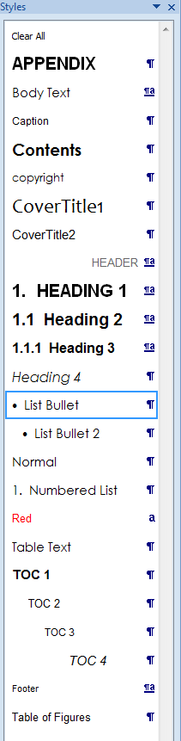Styles are used in this template to format text and allow for the automatic generation of the Table of Contents.

## Using styles

All Headings in this template have styles attached to them (ie Heading 1 to 3).

To see all Styles used in the document, expand the Styles panel on the Home ribbon, by clicking the arrow at the bottom right hand corner.

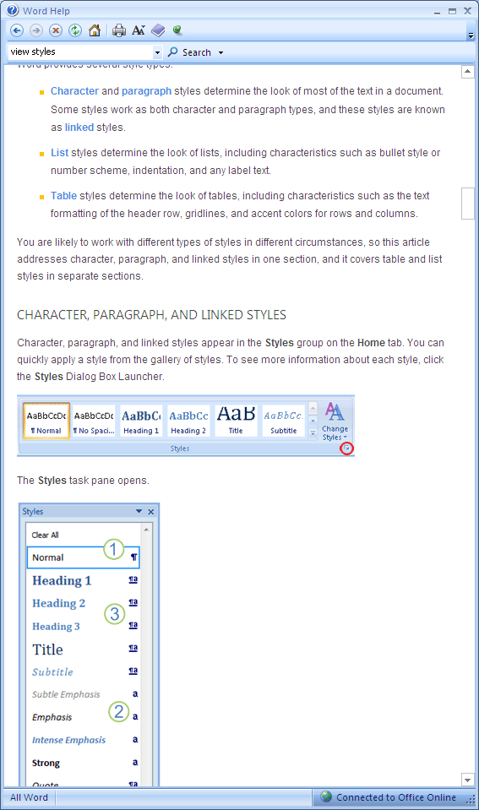

Styles panel

* You can check which Style is applied to the text your cursor is currently on by expanding the Styles panel (click the arrow at the bottom right hand corner as shown above). The style used here is a “List Bullet”.
* To change the Style currently applied to your text, expand the Styles panel and select the alternative Style you wish to apply.
* To remove Styles, highlight the text you wish to remove the Style from, expand the Styles panel and select “Clear All style” (first item in Style panel)
* For paragraphs, table text, numbered lists, bullet points, captions and other text items, please use the style “Body text” (Arial, 11 point).

## Page breaks, section breaks and page numbering

* Do not delete the Section breaks after the Table of Contents or after each Chapter.
* If you want to see where the breaks have been used in this report template, click on the show/hide button on the Standard toolbar (2007: Home tab) to view all the formatting marks. Graphical user interface

  Description automatically generated
* When you want to end a page or insert a manual page break, select the **Layout** ribbon**/Breaks/Page.**
* To create landscape pages between portrait pages simply, first select the text then choose the **Layout** ribbon**/Orientation/Landscape**. By using this method, Word will insert section breaks before and after the text automatically.

## Headers and footers

* Headers and footers have already been inserted into this document.
* The text in the Header is a field which will be automatically populated using whatever you text you type and assign to the Heading 1 style.
* Leave the section breaks in after each chapter so that the headers and footers will change for each section. (If you need to insert them manually, select the ribbon for **Layout/Breaks/Section Breaks/Next Page**.)

## Use the Caption feature to label figures and tables

* Use Word’s **Caption feature** to automatically number each item for labelling tables, figures, equations and other items.

### How to label a caption

* Display the **References tab/Captions group/Insert Caption**
* At this point you can type in additional text by placing your cursor after the number in the Caption box or when you return to the editing screen.
* Word will automatically use the Caption style for formatting.

### Figure using the Caption Style example

Insert captions *below* the illustration for Figures



Kerguelen Islands

3900km

Heard and McDonald Islands

1500km

Macquarie Island

[> Caption Sample: >. Also use for table notes]

Figure 1 Headings for Figures use the Caption Style

### Tables using the Caption Style example

Insert captions *above* the illustration for Tables

Table 1: Headings for Tables use the Caption Style

|  |  |  |  |
| --- | --- | --- | --- |
| Sample Table Layout | Sample | Sample | Sample |
| Table Text Sample | 4 | 5 | 6 |
| Table Text Sample | 7 | 8 | 9 |

[> Caption Sample: start caption with >. Also use for figure notes]

## Equation formatting

Use tables (without borders) to position equations. Create blank rows to copy and paste to other locations.

|  |  |  |
| --- | --- | --- |
|  |  | (5.A.1) |

# Troubleshooting graphics and images

Please ensure graphics, images, maps and figures are large enough to be read easily.

If you experience problems with displaying graphics and other objects, you might need to select theNormal style or Clear All for the paragraph (refer instructions on page 4), or format the picture/graphic.

#### How to format the image/graphic

* Select the graphic, then click the right mouse button and choose **Format Picture** to display options

# Style examples

# Heading 1

## Heading 2

### Heading 3

#### Heading 4

Body text

Bulleted list

* Bullet 2
* Bullet 3

1. This is a Numbered List.
2. Numbered List. To restart numbering, **Right click** 🡪 **Restart Numbering**
3. Numbered List. If necessary, to continue numbering, **Right click** 🡪 **Continue Numbering**

# Typical report sections

### Executive summary

### Introduction

### Methods

### Results

### Conclusions

### Recommendations

### References

### Appendices

These sections can be altered to suit your report.

Appendix A

Appendix B



CONTACT

Name

Email

Web

This project is supported with funding from the Australian Government under the National Environmental Science Program.